KidzCoding Hour of Code - Simple Maze

Activity:

In this activity, students will learn how to design a fun maze game in which the player will attempt to drive a car through a maze to reach the finish line. The game makes use of arrow keys and uses **conditionals, loops and x/y coordinates**.

Learning Objectives:

* Learn to receive key inputs
* Understand how to react to collisions between sprites
* Understand basic x/y coordinates

Materials:

* Scratch starter project: <https://scratch.mit.edu/projects/873863970>
* Completed Scratch project:<https://scratch.mit.edu/projects/873858413>

Coding Time!

Open the starter project

All sprites and backgrounds are in the starter project

Coding the car

1. Placing the car

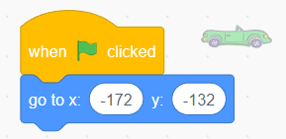

For this step, we will simply place the car at x/y coordinates to the left of the maze

**More on next page**

**2. Moving the car**

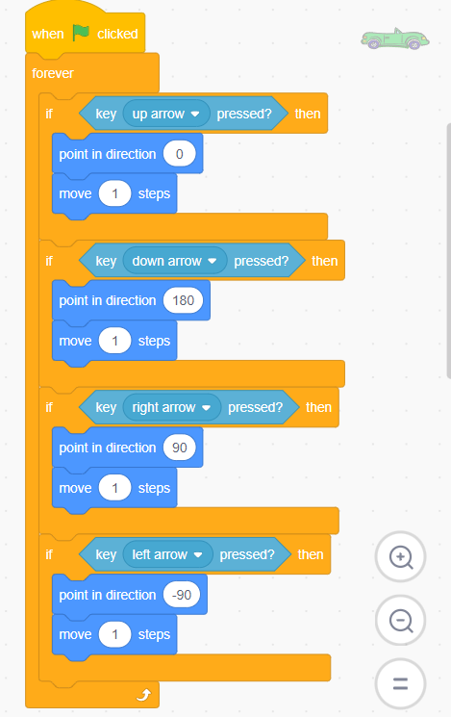

To move the car, we will use our arrow keys. To do this, we use a forever loop so that the code continues running for the entire game. Next we use an if statement and a sensing block for each arrow key, this will cause the code within the if statements to be triggered every time one of the arrow keys is pressed. Next for each arrow key we need to change the direction, 0 degrees is up, 180 degrees is down, 90 degrees is right, -90 degrees is left. Finally, for each if statement after changing the direction of the car, we move the car 1 step.

**Placing the finish line**

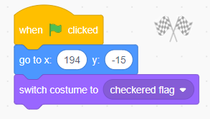

The finish line does not move, so we just place it at the above coordinates and set its initial costume to the checkered flag (provided in stater project).

**Collisions**

1. **Colliding with maze walls**

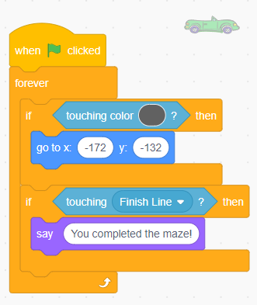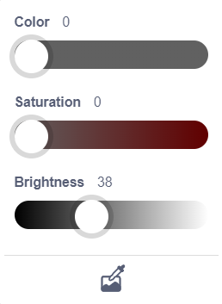

When the car hits the walls, we will reset the player's progress. To do this we if the car is touching the color of the maze wall (provided above) then we will reset the car to its starting position. However, if the car is touching the finish line sprite, we will announce it using the say block. This is done within a forever loop so that the code runs for the entire game and using if statements and sensing blocks to detect if the car is touching the maze wall or the finish line.

1. **Optional: Changing the finish line to a trophy**

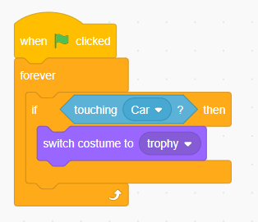

This fun optional step changes the finish line to a trophy when car touches it. We simply use the costumes provided in the start project and use an if statement and the change costume block to change the finish line to a trophy if the car touches it.

**Make more mazes**

If you get bored using the first maze, simply make another one using the backdrop section on Scratch and draw your own.

Note: you will need to use the same color of the maze provided above so the code continues to work.

Congratulations, you have just completed an Hour of Code!